**Lab 5 Ex 1**

**Loan origination – Data Engineering for Financial Service Marketing**

Create a program that produces a .csv file of customers based on demographic characteristics defined by the user.

Provide a 10 row head of the new data frame.

Provide a histogram of the credit score of the customers with the new data frame.

The program must allow for segmentation on multiple variables

Write the marketing list to a .csv file.

**Example output:** A bank in the Twin Cities wants to target customers for student loan consolidation. Create a list of customers from Minnesota who have an active loan, are 30 years of age or younger with a with a household income of over $3000 a month.

Lab 5 Ex 1 Input

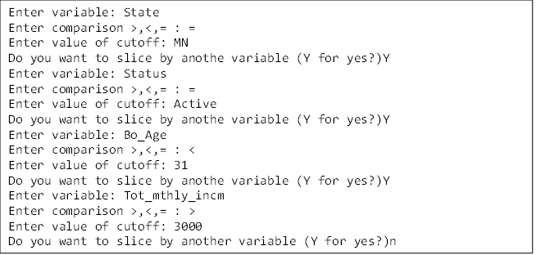

Lab 5 Ex 1 Output ###note format may be slightly different and is not graded on this exercise.

